**Achievement Standard: 91880_1.4** version 1

**Develop a digital media outcome**

**MEDIA OUTCOME EVIDENCE**

**STUDENT NAME:** Liam Rogers

**SUBMISSION NUMBER:** 1

**HAND IN DATE:** 28 / 03 / 2018

|  |  |
| --- | --- |
| **Element 1. Develop a digital media outcome** | |
| Using appropriate tools, techniques and design elements for the  purpose and end users | |
| The basic structure of the website must include the following pages and code  **A** | |
| **1.1_Used appropriate tools** | CSS / HTML EDITOR    IMAGE EDITOR    COLOUR SWATCH |
| **1.2_Home Page** | HEADER PAGE - header.html    HOME PAGE – index.php |
| **1.3_ Contact Page** | CONTACT PAGE |
| **1.4_Three Favourite Foods pages** | FAVOURITE FOODS 1    FAVOURITE FOODS 2    FAVOURITE FOODS 3 |
| **1.5_Basic html structure** | BASIC STRUCTURE OF WEBSITE  I.    II.      III.    IV.    V.    VI.    VII.      VIII.    IX.    X.    XI.    XII.  XIII.    XIV.  XV.  XVI.    XVII.    XVIII.  n/a  XIX.  n/a  XX.    XXI. |
| **1.6_ Basic css structure** | CSS CODE          LINK TO STYLESHEET |
| **1.7_Have clear navigation** | NAVIGATION BAR    NAVIGATION LINKS |
| **1.8_**  **Text is easy to read.** | All text is larger than 12px and makes use of a font that is crisp and clear. I believe this makes every page easy to read.  I have made use of larger headings lists and paragraphs, when required to assist in readability. |

|  |  |
| --- | --- |
| **Element 2. Develop a digital media outcome**  **A** | |
| Applying appropriate data integrity and testing procedures in the  development of the outcome | |
| Student must complete at least two features. | |
| **2.1_Text content is readable**  **Text content is legible**  **<3 spelling errors**  **No grammatical errors** | All text is sized to make it easily readable.  None of it is obscured by images or any other content.  Headings are of an increased size to make then stand out from paragraph text. |
| **2.2_Validation of html** | Paste a screenshot of you USING validation for html.  If some errors are present, this is ok at Achieved level |
| **2.3_Validation of css** | Paste a screenshot of you USING validation for css.  If some errors are present, this is ok at Achieved level |
| **2.4_Website displays, without error, in two different browsers** | BROWSER 1: Internet explorer |
| BROWSER 2 : Name the browser  Paste a screenshot of a website page in that browser. |
| **2.5_Website displays acceptably in screens**  **1024 – 1600** | RESOLUTION -1024x1366  GO TO THIS WEBSITE: http://www.infobyip.com/testwebsiteresolution.php  Paste the URL of your site into the required box  Choose 1024x1366 and click ‘in browser’, then click the Load button  Paste a screenshot below  RESOLUTION -1600x1200  Repeat the above |

|  |  |
| --- | --- |
| **Element 3. Develop a digital media outcome**  **A** | |
| Describing relevant implications  The student must comply with each of the following : | |
| **3.1_Do not use offensive content** | I have use text and images that are suitable for the website. To my knowledge I have not been racist or crossed and any religious boundaries. I have made an effort to ensure that all images and text are none offensive. |
| **3.2_Reference and obtain permission for any content not personally owned** | Content used throughout the website was either given to me by my teacher or gained from Creative Commons.  I am aware that I should obtain permission and reference any content not of my own. |
| **3.3_Mentioned that copyright law should not be breached** | I am aware that I should not break copyright law by using other people’s content and media. |
| **3.4_Reference all images used** | header.html:    index.php:    Affogato.php:    salmon.php:    Filo.php:    Contact.php: |
| **3.5_Accessibility for impaired users** | To cater for accessibility, I have ensured :   * that the Contact page has the correct labels for the Form element. * links have name suited to the content of that link * Heading have an increased font size and bold has been used for emphasis |

**M**

|  |  |
| --- | --- |
| **Element 4. Develop an informed digital media outcome** | |
| Using information from testing procedures to improve the  quality and functionality of the outcome | |
| **4.1_Previewed the site and made changes to the layout / formatting to improve it** | SITE BEFORE REFINEMENT      SITE REFINED |
| **4.2_Asked a volunteer to use the site and made changes based on volunteer feedback** | SITE BEFORE VOLUNTEER REFINEMENT  VOLUNTEER IS: *Classmate*      SITE AFTER REFINEMENT      Colour Contrasting* |
| **4.3_Previewed the site using a slightly smaller (or larger) screen** | The website is fully responsive, having been made using css grid.  Galaxy S5 – 360 x 640  Unresponsive |
| iPad Pro – 1024 x 1366  Unresponsive |
| **4.4_Validation of html** | HTML VALIDATION WITH < 3 ERRORS  Paste a screenshot of you USING validation for html  Must have <3 errors at Merit level  Use - https://validator.w3.org/ |
| **4.5_Validation of css** | CSS VALIDATION WITH < 3 ERRORS  Paste a screenshot of you USING validation for css  Must have <3 errors at Merit level  Use - https://jigsaw.w3.org/css-validator/ |

|  |  |
| --- | --- |
| **Element 5. Develop a digital media outcome**  **M** | |
| Addressing relevant implications | |
| The student must comply with each of the following : | |
| **5.1_Referenced and successfully obtain permission for any content not personally owned** | REFERENCED CONTENT NOT OWNED BY MYSELF   |  |  | | --- | --- | | CONTENT USED | WHERE OBTAINED | | Link for insight on food (home page) | http://www.geniuskitchen.com/ | |
| **5.2_Not have breached any copyright** | I have not broken copyright law, having used content that is either:   * My own * Given to me by my teacher who said it was copyright free * Used content that has a Creative Commons tag, for free use. |
| **5.3_Referenced images used** | IMAGES USED   |  |  |  | | --- | --- | --- | | IMAGE | PAGE USED | REFERENCE | |  | Images |  | |  | Images |  | |  | Images |  | |  | Images |  | |  | Images |  | |
| **5.4_Accessibility demonstrated** | To cater for accessibility, I have ensured :   * all images have an alt tag that is appropriate for the image that can be read by a screen reader for the blind. |

**E**

|  |  |
| --- | --- |
| **Element 6. Develop a refined digital media outcome** | |
| Iterative improvement throughout the design, development and  testing process | |
| Provide evidence of at least four of the following: | |
| **6.1_Manipulated an image to improve the look of the site** | IMAGE BEFORE OPTIMISATION  Paste the image here  IMAGES AFTER OPTIMISATION  Paste the image here  (SAY WHAT YOU DID) |
| **6.2_Reduced image size to reduce load time and overall file size** | ORIGINAL IMAGES FOLDER  Paste screen shot of your file structure, showing the images as they were before you reduced them in size.  FINAL IMAGE FOLDER – All reduced in file size  Paste screenshot of image folder, which shows images reduced close to 100Kb |
| **6.3_Updated html to improve upon layout of site** | HTML BEFORE UPDATE  Paste screenshot here. Make it CLEAR what you are about to update.  HTML AFTER UPDATE  Paste screenshot here.  REASON FOR UPDATE  Make it clear WHY you did this update |
| **6.4_Updated css to improve upon positioning or formatting an element** | CSS BEFORE UPDATE  Paste screenshot here.  Make it CLEAR what you are about to update.  CSS AFTER UPDATE  Paste screenshot here.  REASON FOR UPDATE  Make it clear WHY you did this update |
| **6.5_Passes html validation with no more than 1 error, which does not affect the displayed page** | HTML VALIDATION WITH < 3 ERRORS  Paste a screenshot of you USING validation for html  Must have ≤1 error at Excellence level  Use - https://validator.w3.org/ |
| **6.6_Passes css validation with no more than 1 error, which does not affect the displayed page** | CSS VALIDATION WITH < 3 ERRORS  Paste a screenshot of you USING validation for css  Must have ≤1 error at Excellence level  Use - https://jigsaw.w3.org/css-validator/ |
| **6.7_Updated the css to improve layout or formatting of the website.** | CSS – BEFORE UPDATE ORIGINAL 1  Paste screenshot of the bit of css that you are about to update  **========================================**  CSS – BEFORE UPDATE 1  Paste screenshot of the bit of css that you update  Comment on what this update achieved  **========================================**  CSS – BEFORE UPDATE ORIGINAL 2  Paste screenshot of the bit of css that you are about to update  **========================================**  CSS – BEFORE UPDATE 2  Paste screenshot of the bit of css that you update  Comment on what this update achieved  **========================================**  CSS – BEFORE UPDATE ORIGINAL 3  Paste screenshot of the bit of css that you are about to update  **========================================**  CSS – BEFORE UPDATE 3  Paste screenshot of the bit of css that you update  Comment on what this update achieved  **========================================** |

**E**

|  |  |
| --- | --- |
| **Element 7. Develop a refined digital media outcome** | |
| Applying design elements effectively | |
| The website must show compliance with at least three of the four design principles | |
| **7.1_Contrast**  **Alignment**  **Repetition**  **Proximity** | Paste a screenshot that CLEARLY shows one of these.  Underneath, describe why this is so.  Delete the three not used from the list on the Left |
| **7.1_Contrast**  **Alignment**  **Repetition**  **Proximity** | Paste a screenshot that CLEARLY shows one of these.  Underneath, describe why this is so.  Delete the three not used from the list on the Left |
| **7.1_Contrast**  **Alignment**  **Repetition**  **Proximity** | Paste a screenshot that CLEARLY shows one of these.  Underneath, describe why this is so.  Delete the three not used from the list on the Left |
| The website must have made use of a wireframe during the design process: | |
| **7.2_Wireframe should clearly show all of:**   * **colours used** * **fonts used** * **layout of divs** * **div sizes** * **image detail** | WIREFRAME PROPOSAL  Paste screenshot of the home page wireframe |

|  |  |  |
| --- | --- | --- |
| SUMMARY OF PASS REQUIREMENTS FOR EACH LEVEL | | |
| **TO PASS ACHIEVED** | | |
| ELEMENT | REQUIREMENT | |
| 1 | Using appropriate tools, techniques and design elements for the purpose and end users | |
| 2 | Applying appropriate data integrity and testing procedures in the development of the outcome | |
| 3 | Describing relevant implications | |
| **TO PASS MERIT YOU NEED ALL OF THE ABOVE PLUS** | | |
| 4 | | Using information from testing procedures to improve the quality and functionality of the outcome |
| 5 | | Addressing relevant implications |
| **TO PASS EXCELLENCE YOU NEED ALL OF THE ABOVE PLUS** | | |
| 6 | | Iterative improvement throughout the design, development and testing process |
| 7 | | Applying design elements effectively |

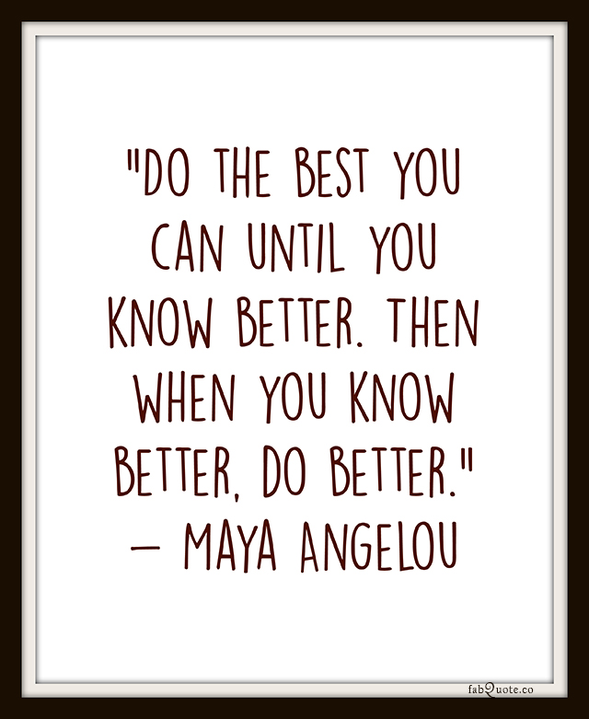

**E**

**M**

**A**